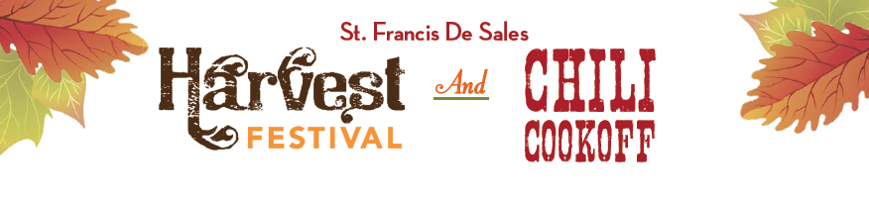

2017 Donation Sheet
Baked Goods, Sodas, Water, Ice Cream Bar

Family Name: ____________________________________________

Items being donated:

_________________________________________________________

Number of items donated:________________________________
(i.e. 2 dz cookies, 1 12 pack of soda, etc. must correspond to what you signed up for on Track it Forward)

Circle the designated area that your donation applies:

Cake Walk Soda/Water/Juice Ice Cream Bar

One of these forms is needed for DIFFERENT Donations, multiples of the same items can be on one sheet.

The Scholarship thanks you for donation and support of the Harvest Festival.

